118 FROM DECIMAL TO BINARY:

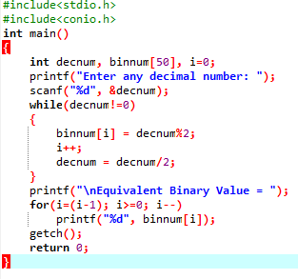

OUTPUT

